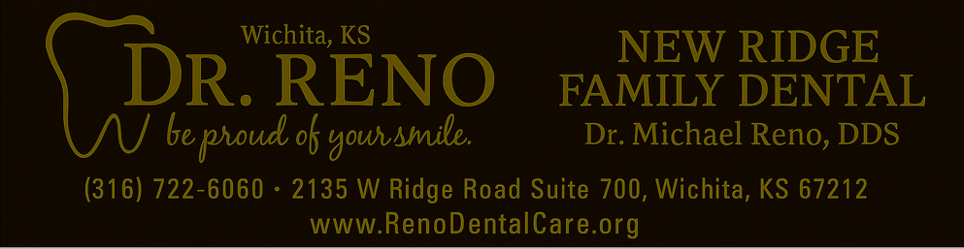
NEW RIDGE FAMILY DENTAL
LIMITED DENTAL WARRANTY GUIDE

This guide explains the limited warranty that may apply to certain dental treatments completed at New Ridge Family Dental.
1) What is a “Limited Dental Warranty”?
A limited dental warranty means that if certain restorations fail under normal use within a stated time period, we may repair or replace the restoration at reduced cost or no cost, depending on the situation and eligibility. Dentistry is not an exact science, and no treatment can be guaranteed to last for a specific length of time.

2) What You Must Do to Keep the Warranty Active (Eligibility Requirements)
To keep the limited warranty valid for eligible restorations, the patient must:
- Complete professional cleanings at New Ridge Family Dental every 6 months with a 2‑month grace period (maximum 8 months between completed cleanings).
- Follow the maintenance schedule recommended by the dentist (for example, periodontal maintenance may be needed more often than every 6 months).
- Maintain good oral hygiene at home (brush and floss daily).
- Wear a nightguard if the dentist recommends one due to clenching/grinding.
- Contact our office promptly if something feels loose, painful, or “high” so we can evaluate and adjust early.
If the required maintenance schedule is not followed, the limited warranty is void.

3) Why We Require 6‑Month Routine Cleanings (and Why It Matters for Warranty)
Restorations last longest when the teeth and gums around them stay healthy. Regular cleanings help because they allow us to:
- Remove plaque and tartar that can cause cavities and gum disease around crowns, bridges, fillings, veneers, and dentures.
- Check margins (the edges) of restorations for early leakage or decay before it becomes a bigger problem.
- Monitor gum health and bone support—gum disease is one of the most common reasons restorations fail early.
- Catch bite changes early (a “high” bite can crack a restoration or the tooth underneath it).
- Document ongoing care—warranty coverage requires proof that the restoration was maintained as recommended.
Think of cleanings like oil changes on a vehicle: they do not guarantee nothing will ever go wrong, but they greatly reduce preventable problems and protect your investment.

4) What the Limited Warranty May Cover
If you remain eligible and a covered restoration fails under normal function, the warranty may cover:
- Repair or ONE replacement/remake of the restoration only, as determined by the dentist.
- The warranty applies to the restoration itself (for example, the crown/bridge/ denture), not to other procedures that may be required.

5) What the Limited Warranty Does NOT Cover (Common Exclusions)
Warranty coverage does not apply when problems are caused by:
- Missing required cleanings/recall visits at New Ridge Family Dental (warranty void).
- New or recurrent decay, gum disease/periodontal disease, bone loss, recession, dry mouth, poor oral hygiene, or delayed care.
- Trauma/accidents (falls, sports injuries, biting unexpected hard objects, etc.).
- Clenching/grinding (bruxism) or not wearing a recommended nightguard.
- Chewing ice, hard candy, popcorn kernels, pens, fingernails, opening packages, or other non‑food/hard items.
- Bite changes or delayed return for needed bite adjustment.
- Treatment performed/altered by another dental office (including recementing/ adjusting the restoration)—this voids the warranty.

6) Costs Not Included (Even If a Restoration Itself Is Covered)
Even if a repair or replacement is covered, the warranty may not include fees for other services such as exams, X‑rays, anesthesia, periodontal treatment, build‑ups, root canals, crown lengthening, extractions, nightguards, relines/soft liners, or other related services.

7) Warranty Timeframes by Treatment
The warranty term starts on the date the final restoration or appliance is delivered/placed.
Treatment | Warranty Term | Notes / Key Requirements
Crowns (Porcelain/Ceramic) | 5 years | Cleanings every 6 months (max 8 months). One repair/remake if covered.
Fixed Bridges | 5 years | Cleanings every 6 months (max 8 months). One repair/remake if covered.
Immediate Temporary Complete Denture (Step 1) | 6 months | Limited coverage for material/fabrication issues only. Healing fit changes are expected.
Immediate Temporary Partial Denture (Step 1) | 6 months | Limited coverage for material/fabrication issues only. Healing fit changes are expected.
Final Complete Denture (Step 2) | 5 years | Cleanings every 6 months (max 8 months). Patients with natural teeth.
Final Partial Denture (Step 2) | 5 years | Cleanings every 6 months (max 8 months). Patients with natural teeth.
Nightguard | 2 years | Cleanings every 6 months (max 8 months). Not covered: loss, pets, heat warping.
Fillings (Composite or Amalgam) | 2 years | Cleanings every 6 months (max 8 months). Not covered: new decay, cracked tooth.
Inlay / Onlay | 2 years | Cleanings every 6 months (max 8 months). One repair/remake if covered.
8) Treatments With NO Warranty
Some procedures and appliances do not include a warranty due to normal healing changes, biologic variability, cosmetic subjectivity, or the unpredictability of trauma/impact. These include:
- Dental bonding (composite bonding)
- Dental flipper (temporary removable partial)
- Dental spacer / space maintainer
- Crown lengthening (periodontal procedure)
- Simple extraction and surgical extraction
- Root canal therapy
- Routine dental cleaning & preventive services
- Scaling & root planing (deep cleaning)
- In‑office whitening
- Nitrous oxide (laughing gas)
- Sports guard (athletic mouthguard)
- Oral biopsy
- Clear aligner orthodontic treatment
- Orthodontic retainers

9) If You Think Something Is Wrong
Please contact New Ridge Family Dental as soon as possible. The dentist will evaluate the restoration and determine warranty eligibility based on clinical findings and compliance with maintenance requirements.

